June 17, 2014

Martin Pietrucha

The Pennsylvania State University

Office of Sponsored Programs

110 Technology Center Building

University Park, PA 16802

RE: PSU/DGS Master Agreement

Work Order No. 010

Notice to Proceed

Dear Mr. Pietrucha:

Attached is one fully executed copy of Work Order No. 010, “Best Practices for the Design, Evaluation and Quality Control of High Percentage RAP Mixes”, initiated under the Intergovernmental Agreement with Pennsylvania State University. This work order provides $55,694 over a twelve (12) month period. The Notice-to-Proceed date is July 1, 2014 and the project completion date is June 30, 2015.

The PennDOT contacts for this project are:

Project/Contract Manager – Heather Heslop, [hheslop@pa.gov](mailto:hheslop@pa.gov), 717-214-9508

Technical Advisor – Tim Ramirez, [tramirez@pa.gov](mailto:tramirez@pa.gov), 717-783-6602

Sincerely,

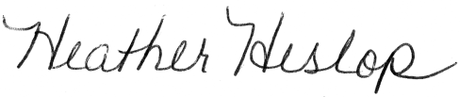

Heather Heslop

Project/Contract Administrator

Bureau of Planning and Research